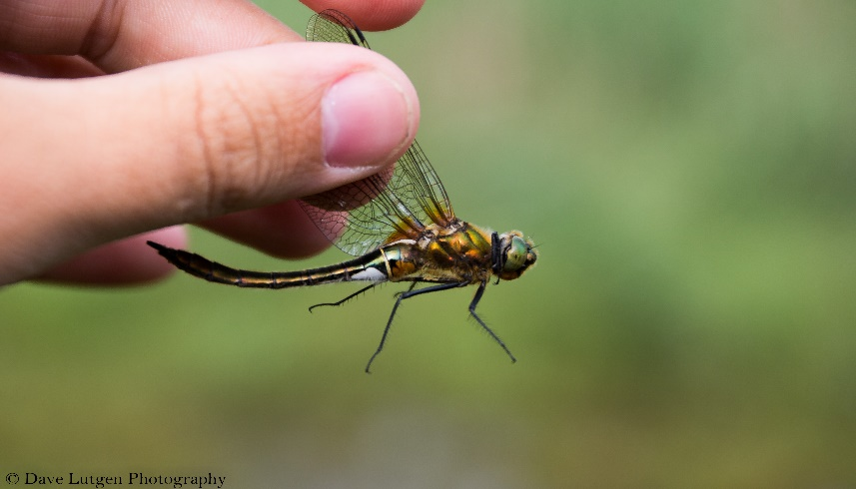
Monitoring of Dragonflies : 01/06/16 – 30/06/16
Brilliant emerald (Somatochlora metallica)
- Species list (Field guide to the dragonflies of Europe)
English | Scientific
- Azure damselfly | Coenagrion puella
- Large red damselfly | Pyrrhosoma nymphula
- Willow emerald damselfly | Lestes viridis
- Blue-tailed damselfly | Ischnura elegans
- Downy emerald | Cordulia aenea
- Emperor dragonfly | Anax imperator
- Beautiful demoiselle | Calopteryx virgo
- Broad-bodied chaser | Libellula depressa
- Scarce chaser | Libellula fulva
- Four-spotted chaser | Libellula quadrimaculata
- Scarlet dragonfly | Crocothemis erythraea
- Banded demoiselle | Calopteryx splendens
- Common darter | Sympetrum striolatum
- Yellow-winged darter | Sympetrum flavoleum
- Brilliant emerald | Somatochlora metallica
- Black-tailed skimmer | Orthetrum cancellatum
- White-legged damselfly | Platycnemis pennipes

